# RPA Documentation

# Photoshop Design Generator

Radu Galan,

Diana-Georgiana Mocanu

Table of Contents

I. Introduction 3

I.1 Purpose of the document 3

I.2 Objectives 3

I.4 Minimum Pre-requisites for automation 3

II.1 Process Overview 4

II.2. Applications used in the process 4

II.3 AS IS Process map 4

II.4 Detailed AS IS Process Steps 5

II.5 Input data description 5

II. To BE Process Description 6

III.1 TO BE Detailed Process Map 6

III.2 Parallel Initiatives/ Overlap (if case) 6

III.3 In Scope for RPA 6

III.4 Out of Scope for RPA 6

III.5 Business Exceptions Handling 7

III.7 Reporting 7

III. Other Observations 7

IV. Additional sources of process documentation 7

# **Introduction**

## I.1 Purpose of the document

The Process Definition Document outlines the business process chosen for automation using UiPath Robotic Process Automation (RPA) technology.

The document describes the sequence of steps performed as part of the business process, the conditions and rules of the process prior to automation and how they are envisioned to work after automating it, partly or entirely. This specifications document serves as a base for developers, providing them the details required for applying robotic automation to the selected business process.

The document describes in detail the process behind the UIpath project entitled “ Photoshop design generator.

## I.2 Objectives

The process that has been selected for RPA is the automation of the creation of simple and nice images respecting some basic rules. The need of wallperpars , simple images or even abstract ones is in continuous rising along with the devices around us and the editing of a simple photo can take a lot of time. This kind of images , plain and simple, are of great value these years ( of course if made right ).

To put it simple, we aim to create a robot that with minimum input and effort will create a big collection of simple images that are supposed to respect a minimum of graphic design principles and guidelines.

The business objectives and benefits expected by the Business Process Owner after automation of the selected business process are:

* *Reduce processing time per item by 50 %*

### 

## I.4 Minimum Pre-requisites for automation

1. *Access to Uipath software ( at least community edition )*
2. *Access to Photshop CC 2019*
3. *A computer with a minimum of 4GB of RAM and 200MB free of disk space*
4. *Access to at least 3 images organised in 3 different folders*

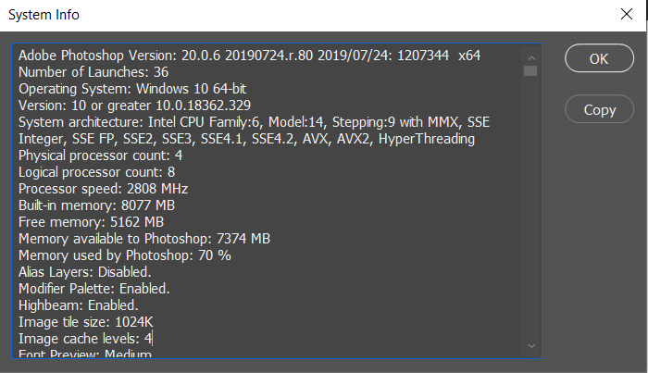

### II.1 Process Overview

General information about the process selected for RPA prior to automation.

|  |  |  |
| --- | --- | --- |
| # | Item | Description |
| 1 | **Process full name** | *Generate graphic design images in photoshop software* |
| 2 | **Process Area** | *Graphic Design* |
| 4 | **Process short description**  (operation, activity, outcome) | Generate a collection of images based on a set of guidelines using as data input 3 folders of images and predefined effects in Photoshop |
| 6 | **Process schedule and frequency** | *Any time, not regular* |
| 7 | **# of items processes /reference period** | ~80’000 images generate/day |
| 8 | **Average handling time per item** | ~1 min |
| 13 | **Level of exception rate** | *A medium range of exceptions covered* |
| 14 | **Input data** | Images in any format |
| 15 | **Output data** | Image in .png format |

## II.2. Applications used in the process

The table includes a comprehensive list all the applications that are used as part of the process automated, at various steps in the flow.

|  |  |  |  |  |  |
| --- | --- | --- | --- | --- | --- |
| # | Application name & version | System  Language | Thin/Thick Client | Environment/  Access method | Comments |
| 1 | Photoshop CC 2019 | EN | Thick Client | Desktop Application | Photo editing |
| 2 | Windows explorer | - | Thin Client | Windows Built-In Application | Basic Software |

*\*Add more rows to the table to include the complete list of applications.*

### 

## II.3 AS IS Process map

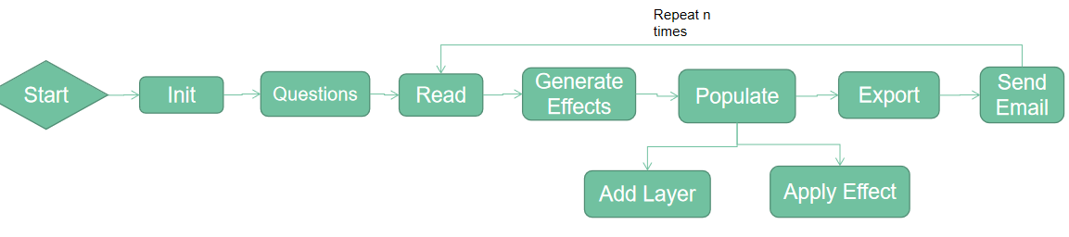

## II.4 Detailed AS IS Process Steps

The robot begins by gathering data about the source directory, the email ( optional ), the name of the resulted photo, the path where to export and the number of times the process should be repeated. Afterwards it will generate a list of random files ( one out of every folder inside the source directory ) and a list of effects ( one for every layer ). It will proceed by opening the Photoshop application, creating a new empty project, populating it with layers containing the photos from the paths generated and then editing them with the effects randomly generated before. In the end it will export the resulted photo in the selected path, send an email to the given email and prepare the work environment for the next generated image ( if it is the case ).

## II.5 Input data description

|  |  |  |  |  |  |  |
| --- | --- | --- | --- | --- | --- | --- |
| Step | Sample  (Printscreen) | Input type | Location | Inputs are standard? (Yes/ NO) | Inputs are structured? | Data to be used from |
| 1 | Img1, img2 | Keyboard from user | n/a | YES | YES | Data Source Images Path |
| 2 | Img3,img4 | Keyboard  From user | N/a | Yes | *---* | Sending emails |
| 3 | Img5 | Keyboard from user | N/a | Yes | *-----* | Saving images name |
| 4 | Img2 | Keyboard from user | N/a | yes | *-----* | Saving image path |

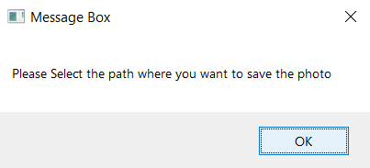 img 1 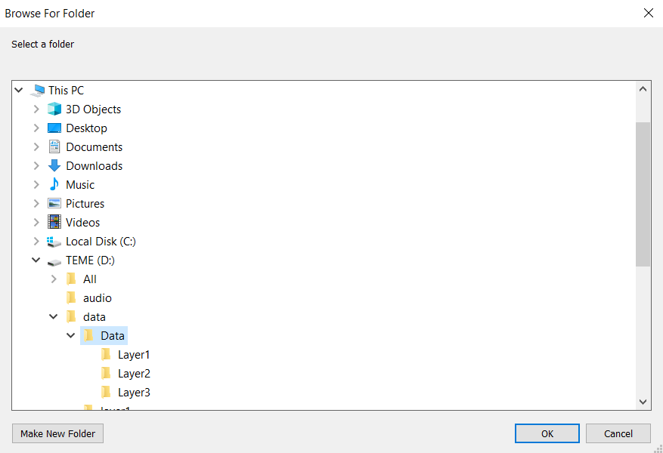img2

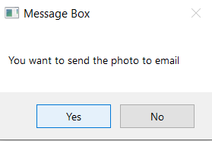img3 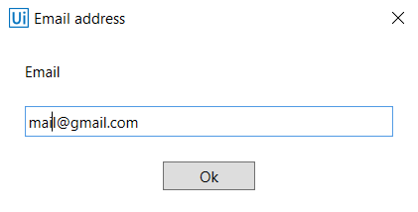img4

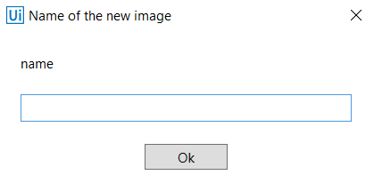img5

# To BE Process Description

This chapter highlights the expected design of the business process after automation.

### 

## III.1 TO BE Detailed Process Map



## III.2 Parallel Initiatives/ Overlap (if case)

This chapter captures the proposed Business, Process & System changes in near future and its impact

|  |  |  |  |  |  |
| --- | --- | --- | --- | --- | --- |
| S.No | Initiative Name | Process Step(s) where it is identified | Impact on current automation request? How? | Expected Completion Date | Contact person for more details |
|  | n/a |  |  |  |  |

## III.3 In Scope for RPA

The activities **in scope of RPA**, are listed here:

## III.4 Out of Scope for RPA

The activities **OUT of scope of RPA**, are listed here:

|  |  |  |  |  |
| --- | --- | --- | --- | --- |
| Sub-process  (if case) | Activity (step) | Reasons for Out of scope* | Impact on the TO BE | Possible measures to be taken into consideration for future automation |
|  |  |  |  |  |

## III.5 Business Exceptions Handling

The Business Process Owner and Business Analysts are expected to document below all the business exceptions identified in the automation process. These can be classified as:

|  |  |
| --- | --- |
| Known | Unknown |
| * The file explorer windows is closed without a file being selected * The sending of the email may fail if the connection to the server isn’t possible or the email isn’t an existing one | New situation never encountered before. It can be caused by external factors. Cannot be predicted with precision, however if it occur. |

#### Known Exceptions

The table below reflects all the business process exceptions captured during the process evaluation and documentation. These are **known exceptions,** met in practice before. For each of these exceptions, define a corresponding expected action that the robot should complete if it encounters the exception.

|  |  |  |  |  |
| --- | --- | --- | --- | --- |
| BE # | Exception name | Step | Parameters | Action to be taken |
| **1** | Closing the save explorer | n/a | Path | **Check the result for bad path** |

## 

## III.7 Reporting

|  |  |  |  |  |
| --- | --- | --- | --- | --- |
| # | Report type | Update frequency | Details | Monitoring Tool to visualise the data |
| ***1*** | Process logs | *On every run* | How many images has it created and if the email sending was successful | -- |

## 

## Other Observations

Include below any other relevant observations you consider needed to be documented here.

*Example: Specific Business monitoring requirements (audit and reporting) etc*

## Additional sources of process documentation

If there is additional material created to support the process automation please mention it here, along with the supported documentation provided.

|  |  |  |
| --- | --- | --- |
| Additional Process Documentation | | |
| **Video Recording of the process [Optional]** | *Refereces to powerpoint presentation* | *Insert any relevant comments* |